**Object Oriented Programming**

**Lab Report**

**Lab09**



|  |  |
| --- | --- |
| Group Members Name & Reg #: | **Muhammad Haris Irfan**  **(FA18-BCE-090)** |
|  |  |
| Class | Object Oriented Programming CSC241 (**BCE-4B**) |
| Instructor’s Name | Maam Amber Madeeha Zeb |

**In Lab Tasks**

5.1 Question 1:

**Code the example given above with mentioning some message indicating the class construction and destruction in the constructors and destructors of each class and check the calling of constructors and destructors.**

**Solution:**

The code is given below,

1 #include<iostream>

2 #include<string>

3 **using namespace std**;

4 **class** studentRecord

5 { **private**:

6 **string** degree;

7 **public**:

8 studentRecord()

9 {

10 **cout**<<"This is class Student record constructor"<<**endl**;

11 }

12 ~studentRecord()

13 {

14 **cout**<<"This is class Student record Destructor"<<**endl**;

15 }

16 **void** getdata()

17 {

18 **cout**<<"Enter Degree: ";

19 **cin**>>degree;

20 }

21 };

22 **class** employeeRecord

23 { **private**:

24 **int** emp_id;

25 **double** salary;

26 **public**:

27 employeeRecord ()

28 {

29 **cout**<<"This is class Employee record constructor"<<**endl**;

30

31 }

32 ~employeeRecord ()

33 {

34 **cout**<<"This is class Employee record Destructor"<<**endl**;

35

36 }

37 **void** getdata()

38 {

39 **cout**<<"Enter Employee ID: ";

40 **cin**>>emp_id;

41 **cout**<<"Enter Salary: ";

42 **cin**>>salary;

43 }

44 };

45 **class** manager

46 { **private**:

47 **string** title;

48 **double** dues;

49 employeeRecord emp;

50 studentRecord stu; **public**:

51

52 manager()

53 {

54 **cout**<<"This is class manager constructor"<<**endl**;

55 }

56 ~manager()

57 {

58 **cout**<<**endl**<<"This is class manager Destructor"<<**endl**;

59 }

60 **void** getdata()

61 {

62 emp.getdata();

63 **cout**<<"Enter Title: ";

64 **cin**>>title;

65 **cout**<<"Enter Dues: ";

66 **cin**>>dues;

67 stu.getdata();

68 }

69 };

70 **int** main()

71 {

72 manager m1;

73

74 **return**(0);

75 }

**Console Output is shown below.**

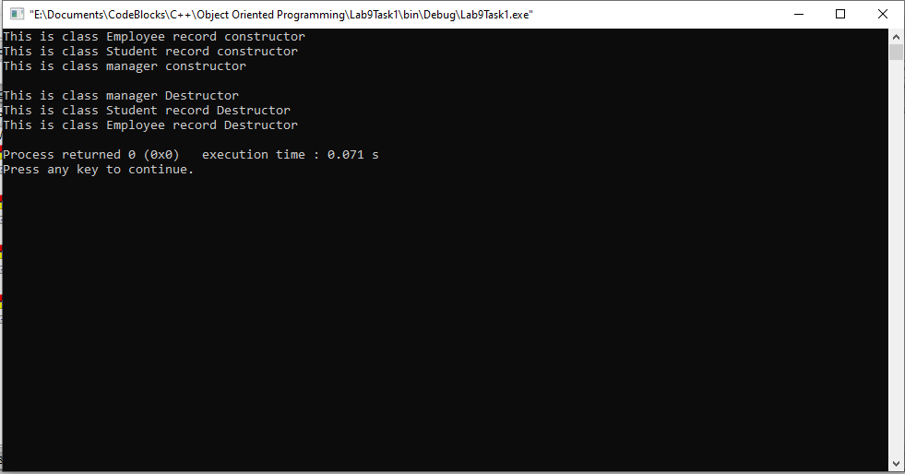

____________________________

5.2 Question 2:

**Create an Address class, which contains street#, house#, city and code (all of type char*). Create another class Person that contains an address of type Address. Give appropriate get and set functions for both classes. Test class person in main.**

**Solution:**The code is given below,

1 #include <iostream>

2

3 **using namespace std**;

4

5 **class** Address

6 {

7 **protected**:

8 **int** street;

9 **int** house;

10 **string** city;

11 **int** citycode;

12

13 **public**:

14 **void** getadd()

15 {

16 **cout**<<"Enter Street number"<<**endl**;

17 **cin**>>street;

18 **cout**<<"Enter House number"<<**endl**;

19 **cin**>>house;

20 **cout**<<"Enter City"<<**endl**;

21 **cin**>>city;

22 **cout**<<"Enter City Code"<<**endl**;

23 **cin**>>citycode;

24

25 }

26

27 **void** showadd()

28 {

29 **cout**<<**endl**<<"Street number:"<<street<<**endl**;

30 **cout**<<"House number:"<<house<<**endl**;

31

32 **cout**<<"City:"<<city<<**endl**;

33 **cout**<<"City Code:"<<citycode<<**endl**;

34

35 }

36 };

37 **class** person

38 {

39 **protected**:

40 Address ad;

41

42 **public**:

43 **void** getadd()

44 {

45 ad.getadd();

46 }

47

48 **void** showadd()

49 {

50 ad.showadd();

51 }

52 };

53

54

55

56

57 **int** main()

58 {

59 person p;

60 p.getadd();

61 p.showadd();

62

63 **return** 0;

64 }

**Console Output is shown below.**

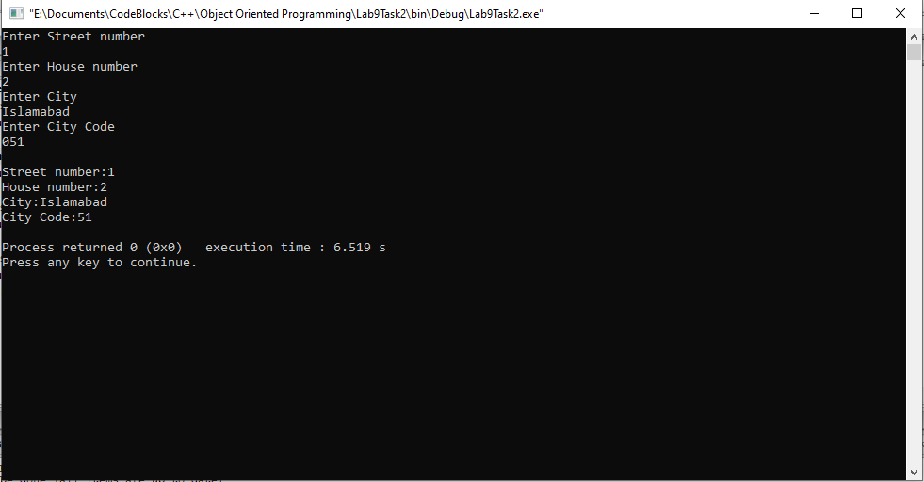

____________________________

5.3 Question 3:

**Write the program, which has two classes one, is Date having members (day, month, year) and the other class is called Employee. The employee has Date class as member as each employee has Date of joining, Date of Birth etc.**

1. **Determine if an employee joined the organization within last five years if the current year is 2012.**
2. **Determine if an Employee has age less than 40 years?**

**Solution:**The code is given below,

1 #include <iostream>

2

3 **using namespace std**;

4

5 **class** Date

6 {

7

8

9

10

11 **public**:

12 **int** dayA, monthA, yearA;

13 **int** dayJ, monthJ, yearJ;

14

15

16 **void** getJoiningdate()

17 {

18 **cout**<<"Enter Joining Day?"<<**endl**;

19 **cin**>>dayJ;

20 **cout**<<"Enter Joining Month?"<<**endl**;

21 **cin**>>monthJ;

22 **cout**<<"Enter Joining Year?"<<**endl**;

23 **cin**>>yearJ;

24 }

25 **void** getbirthdate()

26 {

27 **cout**<<"Enter Birth Day?"<<**endl**;

28 **cin**>>dayA;

29 **cout**<<"Enter Birth Month?"<<**endl**;

30 **cin**>>monthA;

31 **cout**<<"Enter Birth Year?"<<**endl**;

32 **cin**>>yearA;

33 }

34

35

36

37 };

38

39 **class** Employee

40 {

41 **protected**:

42 Date d1;

43 **public**:

44 **void** getdata()

45 {

46 d1.getbirthdate();

47 d1.getJoiningdate();

48 }

49

50 **void** result()

51 {

52 **if**((2012-d1.yearJ) <=5)

53 **cout**<<"The EMPLOYEE joined the organization in last 5 years."<<**endl**;

54 **if**((2012-d1.yearJ) >5)

55 **cout**<<"The EMPLOYEE joined the organization more then 5 years ago."<<**endl**;

56 **if**((2012-d1.yearA) <40)

57 **cout**<<"The EMPLOYEE has age less then 40 years."<<**endl**;

58 **if**((2012-d1.yearA) >=40)

59 **cout**<<"The EMPLOYEE age is not less then 40 years."<<**endl**;

60 }

61

62

63 };

64 **int** main()

65 {

66 Employee e1;

67 e1.getdata();

68 e1.result();

69

70 **return** 0;

71 }

**Console Output is shown below.**

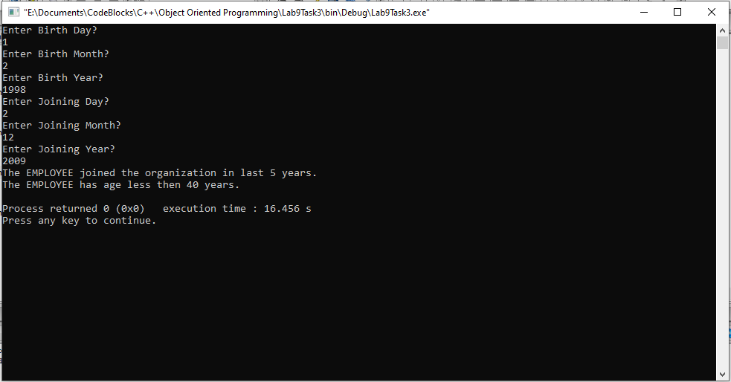

____________________________

POST LAB

6.1 Question 4:

Read digits as Characters input and convert to equivalent numeral values.

Solution:

I am attaching my code below,

1 #include <iostream>

2

3 **using namespace std**;

4

5 **int** main()

6 {

7 **char** name;

8 **int** x;

9 **cout** << "Give any character input?" << **endl**;

10 **cin**>> name;

11

12 x=name;

13

14 **cout**<<"The integer equivalent of entered character is: "<<x;

15

16

17

18 **return** 0;

19 }

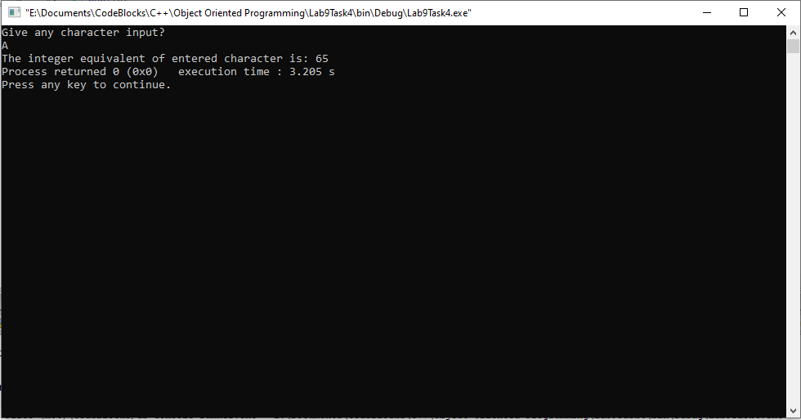**The result for this program is shown below,**

________________

______THE END________

_______________